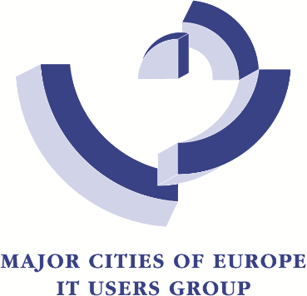
Welcome to the
MCE Community

MEMBERSHIP APPLICATION for Local Governments, Public Organisations, Universities, Research Institutions and Association
TERMS AND CONDITIONS
You are welcome to join MCE, the Major Cities of Europe – IT Users Group! Membership is open to Local Governments, Public organisations, Research Organisations / Universities, Associations that value innovation and wish to share experiences, projects, and initiatives with colleagues from other organisations and countries. Each member is represented by a contact person.
The membership fee is charged annually and covers the period January to December. Membership officialised during the year will be charged proportionally to the number of months until the end of the year. These are the 2026 membership fees:
- 350 Euro: Universities, Research Institutions and Associations
- 600 Euro: Local Governments or Public Organisation addressing less than 100.000 inhabitants
- 1000 Euro: Local Governments or Public Organisation addressing 100.000 to 500.000 inhabitants
- 1600 Euro: Local Governments or Public Organisation addressing 500.000 to 1.000.000 inhabitants
- 2000 Euro: Local Governments or Public Organisation addressing more than 1.000.000 inhabitants
Each member can resign by written communication. Resignation will become effective the following year. Membership gives access to all MCE activities, including the participation to the annual conference, workshops, webinars, etc. For more information, please refer to our Statutes on our website at www.majorcities.eu .

Salutation: Mr. ☐ Ms. ☐ Title:

First Name: Last Name:

Organisation: Job Title:

Street, No.: Country:

Zip: City:

Phone : Mobile :

E-mail : LinkedIn

Population if Local Government _________ ___________________________________________

Date, signature, and stamp of the organization:

Confirmation that you accept the terms & conditions - Signature:

